Su92-bsaim-f24-006

BSAI-4A
PROJECT Title: Fake News Detection
PROJECT Deliverables: Using NLP & FLASK
GITHUB LINK : https://github.com/Sadii2005/programming-for-AI-LAB

Introduction
With the rapid growth of digital media, fake news has become a serious issue that affects public opinion and decision-making. This project aims to develop an intelligent system that can automatically detect whether a news article is real or fake using Natural Language Processing (NLP) techniques and machine learning models.

Objectives
To build a system that classifies news as real or fake
To apply NLP techniques for text preprocessing and analysis
To develop a machine learning model for accurate prediction
To create a user-friendly web interface using Flask

Methodology
Data Collection:
Use a dataset containing real and fake news articles
Data Preprocessing:
Remove stopwords
Tokenization
Lowercasing
Text cleaning
Feature Extraction:
TF-IDF (Term Frequency–Inverse Document Frequency)
Model Building:
Apply algorithms like Logistic Regression or Naive Bayes
Model Evaluation:
Accuracy, Precision, Recall
Deployment:
Integrate model with Flask web application

Technologies Used
Python
Natural Language Processing (NLP)
Scikit-learn
Flask
HTML/CSS

Project Deliverables
Text classification model (Fake vs Real news)
NLP-based preprocessing pipeline
Feature extraction using TF-IDF
Flask-based web application
User input interface for news text
Real-time prediction output
Model performance evaluation
Project report and documentation
Source code implementation

WORKING FLOW
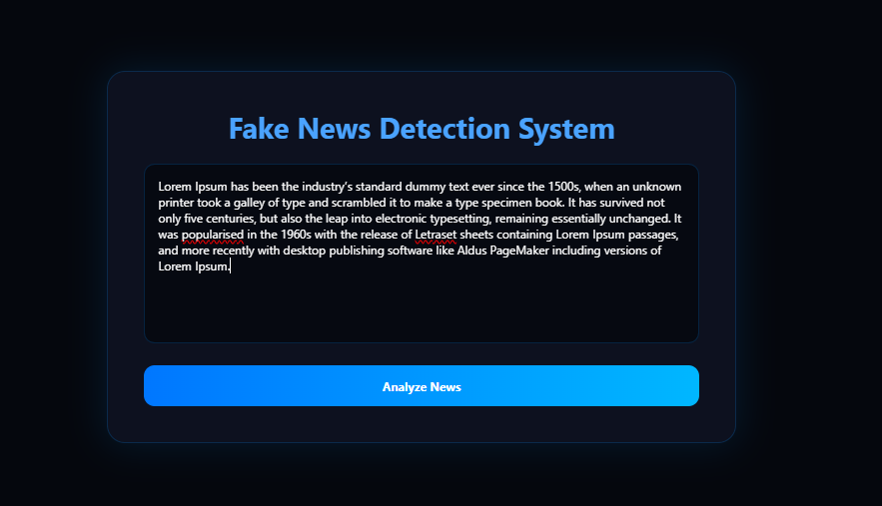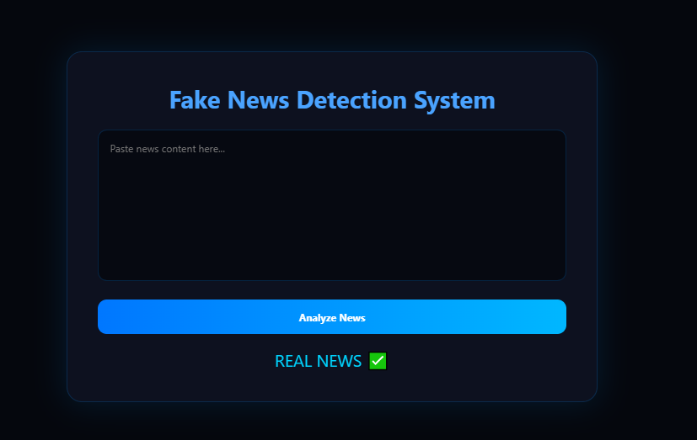

Expected Outcome
The system will allow users to input news content and receive a prediction indicating whether the news is fake or real, helping in reducing misinformation.

Future Enhancements
Integration with live news APIs
Deep learning models (LSTM, BERT)
Multilingual fake news detection
Browser extension for real-time detection

